**MID- TERM TEST – NO 03**

READING AND WRITING

***Time allowed: 45 minutes***

**1. Which notice (A-H) says this (1-5)? Mark the correct letter A-H on your answer sheet.**

|  |  |
| --- | --- |
| 1. You can get a car at any time. 2. You pay the same price but you get more. 3. In the evening, children may not come in. 4. There are two prices for tickets. 5. You can buy food here on Sunday. |  |

**2. Read the sentences about cooking. Choose the best word (A, B or C) for each space.**

6 Claudia…………. some fruit and vegetables from the market.

A bought B kept C grew

7 She cut up some meat and onions and fried them in pan on the ………………

A cooker B cupboard C fridge

1. There was a big …………….. of salad to eat afterwards.

A bottle B bowl C spoon

1. When everything was …………….., they all sat down at the table.

A real B round C ready

1. After dinner, Claudia’s parents …………….. her to wash up.

A practiced B agreed C helped

11 Claudia is really fond of …………….

A cooking B cook C cooked

**3.Choose A, B or C to complete the five conversations.**

12 Who’s that man with the green sweater? A He’s my brother.

B It’s John’s.

C I don’t know it.

13 Where’s Amanda gone? A She’s at the station.

B She’ll arrive tomorrow.

C She’s going to leave tonight.

14 I hate shopping. A So do I.

B Certainly.

C That’s all right.

15 How long did the journey take? A About 500 kilometres.

B Almost 5 hours.

C Last week.

16 The room costs £55 a night. A I don’t take it.

B Give me two, please.

C That’s a lot.

**4. Read the article about Corryvale Farm. For question 17 – 23, mark A, B or C on your answer sheet.**

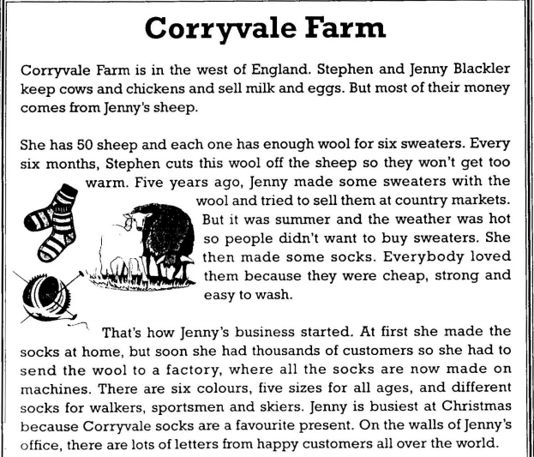

**17** Jenny only gets wool from her sheep once a year.

A Right B Wrong C Doesn’t say

**18** It took Jenny a long time to make the sweaters.

A Right B Wrong C Doesn’t say

**19** Jenny couldn’t sell the sweaters because it was the wrong time of year.

A Right B Wrong C Doesn’t say

**20** Jenny decided that socks were easier to make than sweaters.

A Right B Wrong C Doesn’t say

**21** Corryvale socks are still made on the farm.

A Right B Wrong C Doesn’t say

**22** You can’t buy Corryvale socks for children.

A Right B Wrong C Doesn’t say

**23** People from many different countries buy Corryvale socks.

A Right B Wrong C Doesn’t say

**5. Read information about farming. Choose the best word A, B or C for each space.**

|  |
| --- |
| ***The History of Farming***  Before people started farming, they went to the forest to look for plants or fruit they could eat. This meant that people (24) ……. moving all the time to find food. But about 12,000 years ago, in the Middle East, people (25) ……. to grow food. These people were the first farmers. Farming made (26) ……. possible for people to stay in (27) ……. place and slowly their villages got bigger.  Some people in the villages became free to do other work, like making clothes, (28) ……. the farmers could grow food for everyone. Unfortunately, farming was difficult when the weather was bad and then some people did not get (29) ……. food to eat.  Today, farmers (30) ……. grow more food and it travels thousands of kilometres from where it (31) ……. grown to our homes. |

24 A was B been C were

25 A began B begin C begun

26 A this B it C them

27 A one B the C other

28 A but B or C because

29 A enough B all C many

30 A need B can C have

31 A be B being C is

**6. Read the descriptions of some holiday words? What is the word for each one? There is one space for each other letter in the word.**

|  |  |
| --- | --- |
| 32 You may need to show this when you travel to a foreign country  33 The pictures you take with this will help you remember your holiday.  34You can sit on this on the beach or use it to dry yourself.  35 Make sure this is big enough to hold all your clothes for your holiday.  36 It’s good to read this on the beach or in an aeroplane.  37 You wear these to protect your eyes from bright light from the sun. | p _ _ _ _ _ _ _  c _ _ _ _ _  t _ _ _ _  s _ _ _ _ _ _ _  m _ _ _ _ _ _ _  s _ _ _ _ _ _ _ _ _ |

**7. Read the advertisement and the letter about the Young People’s Camp. Fill in the information on the application form.**

|  |
| --- |
| *Rose Cottage*  *Northfleet*  *26 March*  *To: Weston University Library*  *My teacher, Robin Gibson, has told me to read Understanding Science before my exam on 17th April. I am on holiday in Northfleet at the moment but I’ll return to my home at 22 King’s Road, Weston on 9th April. I’d like to get the book the next day and keep it for one week. It’s by S J Jenshaw. Thank you*  *Mary Jones* |

|  |  |  |  |  |  |  |  |  |  |  |  |  |  |  |  |  |  |  |  |  |  |  |  |  |  |  |  |
| --- | --- | --- | --- | --- | --- | --- | --- | --- | --- | --- | --- | --- | --- | --- | --- | --- | --- | --- | --- | --- | --- | --- | --- | --- | --- | --- | --- |
| **Weston University Library**  **Reservation Form**  Name of book: Understanding Science   |  |  |  | | --- | --- | --- | | Name of writer: | **38** |  | |  |  |  | | When do you want the books? | **39** |  | |  |  |  | | For how long? | **40** |  | |  |  |  | | Student’s name: | **41** |  | |  |  |  | | Student’s address: | **42** |  | |

**8. Write about 25-35 words on your answer sheet.**

I’ll make the meal tonight. Would you like meat or fish? What vegetables do you want? What time will you be at home?

Best wishes,

Eric.